Министерство образования Республики Беларусь

Учреждение образования

БЕЛОРУССКИЙ ГОСУДАРСТВЕННЫЙ УНИВЕРСИТЕТ

ИНФОРМАТИКИ И РАДИОЭЛЕКТРОНИКИ

Факультет компьютерного проектирования

Кафедра инженерной психологии и эргономики

Базы данных

ОТЧЁТ

по лабораторной работе №6

«Транзакции»

Выполнил                                                                   Студент: гр.310901                                                                                 Усов А. М.

Проверила                                                                                 Воробей А. В.

Минск 2025

Транзакция 1. Лабораторная №4:

begin;

select * from user_ u where u.produceruserid is null;

select * from dream d where d.price < 25;

select * from "role";

select * from payment p where p.orderid = 'c219a71c-a74f-4396-bda5-84e0e7b5c521';

select * from review r where userid = '0b6ad028-8582-432b-af34-e83f090760a4';

select * from dreamcategory d ;

select

o.userid ,

d.title ,

d.price ,

xref.count

from order_ o

join orderdreamxref xref on o.orderid = xref.orderId

join dream d on xref.dreamid = d.dreamid

where o.orderid = '56002ce6-b61b-44b1-bf8e-6456a173d076';

select * from producer p ;

select p.title ,pu.secretkey , u."name"

from produceruser pu

join producer p on p.producerid = pu.producerid

join user_ u on pu.produceruserid = u.produceruserid

where p.title = 'Lucid Labs';

select p.producerid, d.title, d.price from dream d

join producer p on d.producerid = p.producerid

where p.title = 'Lucid Labs';

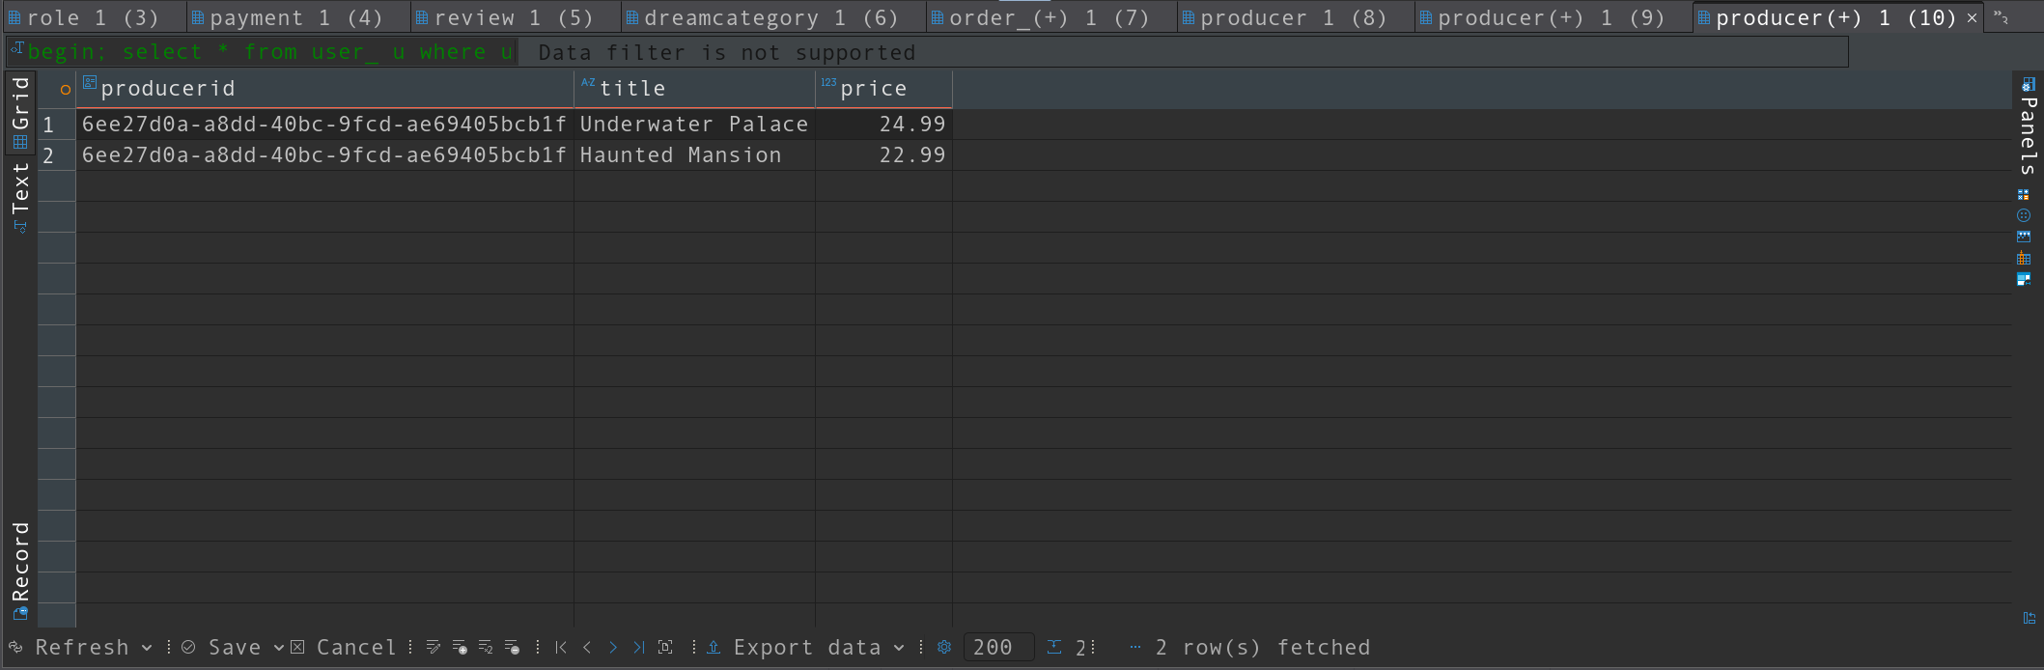commit;

Транзакция 2. Лабораторная №5:

begin;

SELECT

p.Title AS producer_title,

COUNT(d.dreamid) as dream_count

FROM Producer p

JOIN Dream d ON p.ProducerId = d.ProducerId

GROUP BY p.Title

HAVING COUNT(d.DreamId) >= (

SELECT AVG(dream_count)

FROM (

SELECT COUNT(DreamId) AS dream_count

FROM Dream

GROUP BY ProducerId

) AS counts

);

SELECT

u.Name,

AVG(r.Rating) AS avg_rating

FROM User_ u

JOIN Review r ON u.ConsumerUserId = r.UserId

GROUP BY u.ConsumerUserId, u.Name

HAVING AVG(r.Rating) > 4.0

ORDER BY avg_rating DESC;

SELECT ConsumerUserId, Name FROM User_

EXCEPT

SELECT DISTINCT u.ConsumerUserId, u.Name

FROM User_ u

JOIN Order_ o ON u.ConsumerUserId = o.UserId;

SELECT d.DreamId, d.Title

FROM Dream d

JOIN OrderDreamXRef odx ON d.DreamId = odx.DreamId

INTERSECT

SELECT DreamId, Title

FROM Dream;

WITH RankedDreams AS (

SELECT

d.Title AS dream_title,

dc.Title AS category,

d.Price,

ROW_NUMBER() OVER (PARTITION BY dc.DreamCategoryId ORDER BY d.Price DESC) AS rn

FROM Dream d

JOIN DreamCategoryDreamXRef dcdx ON d.DreamId = dcdx.DreamId

JOIN DreamCategory dc ON dcdx.DreamCategoryId = dc.DreamCategoryId

)

SELECT dream_title, category, Price

FROM RankedDreams

WHERE rn <= 3;

SELECT

p.Title AS producer,

SUM(d.Price * odx.Count) AS total_revenue

FROM Producer p

JOIN Dream d ON p.ProducerId = d.ProducerId

JOIN OrderDreamXRef odx ON d.DreamId = odx.DreamId

JOIN Order_ o ON odx.OrderId = o.OrderId

GROUP BY p.ProducerId, p.Title

ORDER BY total_revenue DESC;

-- Пользователи, оставившие отзывы на ВСЕ сны от 'DreamWorks Studio'

SELECT u.Name

FROM User_ u

WHERE NOT EXISTS (

-- Найти сон от DreamWorks Studio, на который у пользователя НЕТ отзыва

SELECT d.DreamId

FROM Dream d

JOIN Producer p ON d.ProducerId = p.ProducerId

WHERE p.Title = 'DreamWorks Studio'

EXCEPT

SELECT r.DreamId

FROM Review r

WHERE r.UserId = u.ConsumerUserId

);

SELECT 'Dream Average Rating' AS metric, AVG(Dream.price) AS value

FROM Dream

UNION ALL

SELECT 'Review Average Rating', AVG(Rating)

FROM Review;

SELECT u.Name, u.Email

FROM User_ u

WHERE EXISTS (

SELECT 1 FROM Order_ o WHERE o.UserId = u.ConsumerUserId

)

AND NOT EXISTS (

SELECT 1 FROM Review r WHERE r.UserId = u.ConsumerUserId

);

SELECT 'Average Dream Price' AS metric, AVG(Price) AS value

FROM Dream

UNION ALL

SELECT 'Average Review Rating', AVG(Rating)

FROM Review;

commit;

